**Terms of Reference (TOR)**

**Installation of Open Paddock (Iron Pipe Fencing)**

1. **Background:**

Heifer Project Nepal (HPN) is implementing a project entitled “Dairy productivity improvement support project through digital and green transformation of small farming community in Kamalamai City, Nepal” funded by KOICA.

As an initiative for Climate Smart Dairy Farming as per the mission statement of Heifer “Caring for the Earth” and as envisioned in the project, it has been planned to install the open paddock near the cowsheds.

1. **Objective of the Service:**

Installation of Open Paddock as the Korean heifers are already getting pregnant, they need daily routine exercise in open space where abundant sunlight is available.

1. **Scope of the work:**

Open Paddock that we are going to procure will be based on the specifications and the drawing design provided in annex 1 below. The company/firms/suppliers should clearly mention the validity of the quoted price.

1. **Items to be procured:**

Installation of Open Paddock in 51 household with cement, sand and all iron work including welding, fitting, and painting.

1. **Supply and Delivery Location:**

Kamalamai Municipality Ward No 5, Sindhuli (Exact location will be finalized at the time of contract)

1. **Mode of payment:**
2. The payment shall be made to the account of company/firms/suppliers.
3. The payment will be made through Account Payee Cheque or Bank Transfer.
4. **Evaluation criteria:**

HPN will evaluate the proposal based on the criteria below out of 100.

1. Price – 60% (It includes the face value or cost of acquisition including delivery and installation charges, life cycle cost, i.e, the repairs and maintenance cost)
2. Quality - 30% (Comply with Heifer’s required specifications, quality and reputation of the goods/services, past track record)
3. Management- 10% (The capacity of vendor, the vendor experience in the NGO sectors, delivery terms and conditions)
4. **Acceptance of quotation:**

All rights to accept or reject partially/ wholly quotation, with or without giving any reasons, shall reserve with HPN. If deemed necessary, the company/firms/suppliers shall be asked for modifications.

1. **Management of the service:**

The selected company/firms/suppliers shall be accountable for the supply, delivery and installation of paddock as per specification and instruction of site in charge within 25 days after contract execution.

1. **Documents to be submitted by the company/firms/suppliers:**

The application should contain following documents:

1. Sign and stamp in all pages on Terms of Reference (TOR) and complete Annex II
2. Company/firms/suppliers registration certificate
3. PAN/VAT certificate
4. Tax Clearance Certificate FY 079/80 or tax clearance extension slip

Please submit the sealed quotation along with above documents to address below by **16th November 2023, 5: 00 PM**. Please clearly mark in the envelope “Sealed quotation for installation open Paddock.”

**Note:** Sindhuli based vendors are encouraged to apply.

**Heifer Project Nepal**

Lalitpur Metropolitan City, Ward No:15, Hattiban, Lalitpur

Ph.no.: 977-1-5913554, 5913120

Email: [procurement-np@heifer.org](mailto:procurement-np@heifer.org)

**ANNEX I: Technical Specification**

1. **Open Paddock Materials Specifications**

|  |  |  |
| --- | --- | --- |
| **SN** | **Item** | **Item Description (Specifications)** |
| 1 | Supplying, cutting, welding and fitting of Iron work for open Paddock fencing including the red oxide and black enamel painting in all iron works. | **Vertical post:** 40mm round iron pipe 2mm thick, **Horizontal Pipe:** 32mm round iron pipe 2mm thick, **Angle for support:** 20mm*20mm*3mm,  **Iron rod for hole pass:** 8mm iron rod in cross for post hole pass |
| 2 | Cement | 43 grade OPC cement, NS standard |
| 3 | Sand | Coarse sand from river |

**Open Paddock Drawing:**

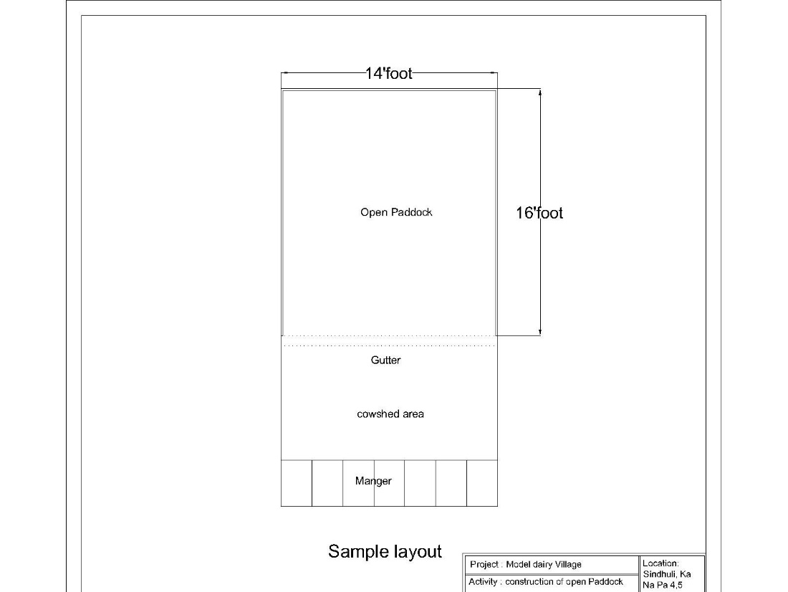

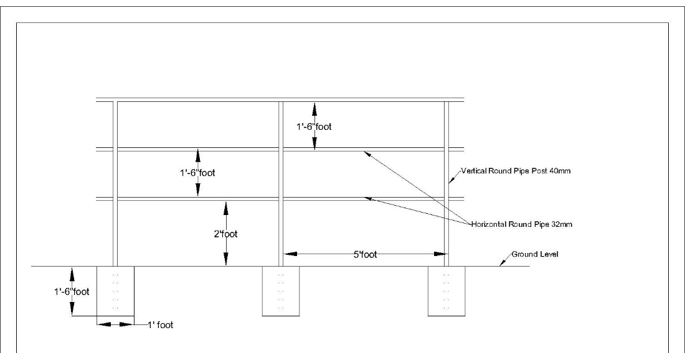

**ANNEX II: Quotation/Bidding Form**

|  |  |  |  |  |  |  |
| --- | --- | --- | --- | --- | --- | --- |
| **Bill of Quantity** | | | | | | |
| **S.N.** | **Item** | **Item Description (Specifications** | **Unit** | **Quantity** | **Rate (NPR)** | **Amount** |
| 1 | Supplying, cutting, welding and fitting of Iron work for open Paddock fencing including the red oxide paint and black enamel painting in all iron works. | Vertical post: 40mm round iron pipe 2mm thick, Horizontal Pipe: 32mm round iron pipe 2mm thick, Angle for support: 20mm*20mm*3mm, Iron rod for hole pass: 8mm iron rod in cross for post hole pass | Kg | 5,478.12 |  |  |
| 2 | Cement | 43 grade OPC cement NS standard | Bag | 102.00 |  |  |
| 3 | Sand | Coarse sand from river | Cum | 48.00 |  |  |
| **Sub Total** | | | | | |  |
| Vatable item (1+2) | | | | | |  |
| Vat @ 13 % | | | | | |  |
| **Grand Total** | | | | | |  |

**Name of Company/firm/supplier**:

Contact Name:

Contact No:

Email:

Contact Address:

Website:

Signature:

Date:

Company/firm Stamp: